Hello,

The Out Of Office is set up using the link on the main NCAARINFO.org home page:

1.  Go to <https://www.ncaarinfo.org/>

2.  Click the Out Of Office in the top banner:

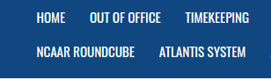

3. On the new page, enter your normal Roundcube credentials

                        (Your personal username is **<username>** and your password is your date of hire <**mm/dd/yy>** )

4. Select “Automatic Reply” on the left side of the screen:

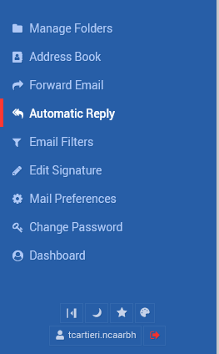

5. Enter the following information on the Automatic Reply screen:

                        a) Automatic response enabled? “YES”

                        b) Your desired Reply message, with pertinent information

                        c) Don’t send autoreply after………select the date ***before your return*** (For example, if you are returning on Monday 4/19, you would enter Sunday 4/18)

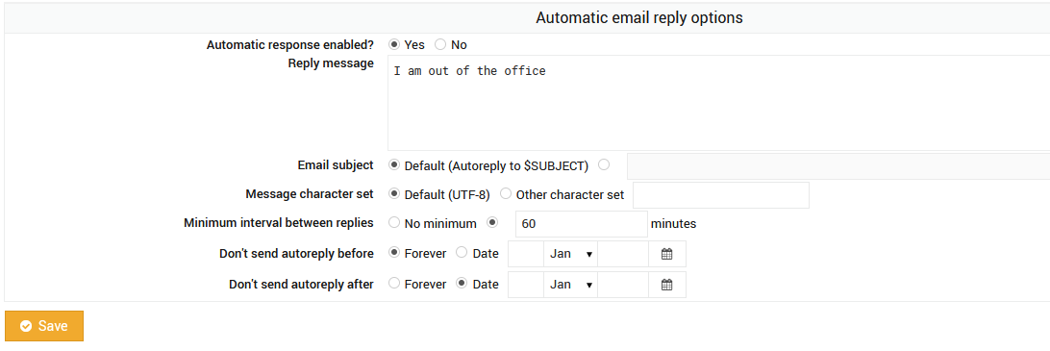

6. Finally, select “Save” and you are all set!

**Note:**  The Out Of Office reply will begin within 30 mins of all this, so it’s best to set it before leaving for the day ☺